

“OCEANVISIONNET: REAL-TIME MARINE PLASTIC WASTE DETECTION USING UAV VISION, YOLOv12, AND SEGMENT ANYTHING MODELS”

A CAPSTONE PROJECT REPORT
Submitted in the partial fulfilment for the Course of
DSA0204 – COMPUTER VISION WITH OPENCV
to the award of the degree of
BACHELOR OF ENGINEERING
IN
CSE (AI & DS)
Submitted by
BHAVYA P.S (192524017)
MONIKA M (192324109)
S RAMYA (192524368)
Under the Supervision of
DR. SENTHIL G A

SIMATS ENGINEERING
Saveetha Institute of Medical and Technical Sciences
Chennai-602105
SEPTEMBER 2026

DECLARATION
I, Bhavya P.S (192524017) of the Department of Computer Science / Artificial Intelligence and Data Science, SIMATS Engineering, Saveetha Institute of Medical and Technical Sciences, Chennai, hereby declare that the Capstone Project Work entitled “OceanVisionNet: Real-Time Marine Plastic Waste Detection Using UAV Vision, YOLOv12, and Segment Anything Models” is the result of our own bonafide efforts. The work has been carried out for the course DSA0204 – Computer Vision with OpenCV and is prepared in accordance with the academic requirements of SIMATS Engineering.
To the best of our knowledge, the work presented herein is original and all sources, references, datasets, software resources and external materials used in preparing the project have been appropriately acknowledged. The results stated in the supplied project presentation are presented as expected/projected results unless experimentally validated in the implementation.
Place: Chennai
Date: ____________________

Signature of the Students with Names:
Bhavya P.S (192524017)

BONAFIDE CERTIFICATE
This is to certify that the Capstone Project entitled “OceanVisionNet: Real-Time Marine Plastic Waste Detection Using UAV Vision, YOLOv12, and Segment Anything Models” has been carried out by Bhavya P.S (192524017) under the supervision of Dr. Senthil G A and is submitted in partial fulfilment of the requirements of the B.E. program at SIMATS Engineering, Chennai.
Course: DSA0204 – Computer Vision with OpenCV
Faculty: Dr. Senthil G A
Department: CSE (AI & DS)
Course Faculty Signature: ____________________
Head of the Department Signature: ____________________
Course Coordinator Signature: ____________________

Course Coordinator: : Dr. Narendra Kumar  Designation : Professor  Department : Intelligent Computing  SIMATS Engineering,  SIMATS, Chennai - 602105 | Course Faculty: Dr G.A.Senthil  Designation : Professor  Department : Cloud Computing  SIMATS Engineering,  SIMATS, Chennai - 602105

INDIVIDUAL CONTRIBUTION STATEMENT
The following module allocation is provided in an editable form based on the three-module project structure in the supplied presentation. Update the responsibility details and percentages if the team's actual contribution differs.
Name / Register No. | Specific Responsibilities | Design & Development Contribution | Testing & Analysis Contribution | Report Contribution | Approx. Contribution (%)
Bhavya P.S / 192524017 | Module 1 – Data Acquisition using UAV Vision | UAV image/video acquisition workflow and preprocessing interface | Checked aerial-image inputs and acquisition workflow | Chapters 1, 3 and Module 1 documentation | 33.3%
Monika M / 192324109 | Module 2 – Plastic Waste Detection using YOLOv12 | Object-detection workflow, bounding boxes and confidence outputs | Checked detection outputs and confidence reporting | Chapters 2, 4 and Module 2 documentation | 33.3%
S Ramya / 192524368 | Module 3 – Waste Segmentation and Mapping using SAM | Segmentation-mask generation, waste-area estimation and mapping | Checked segmentation boundaries and mapped outputs | Chapter 5, results and Module 3 documentation | 33.4%
Total |  |  |  |  | 100%

ABSTRACT
Marine plastic pollution is a growing environmental problem that affects marine ecosystems and creates a need for faster and more reliable monitoring. Traditional approaches such as manual beach and ocean surveys, ship-based visual inspection, satellite monitoring and conventional image-processing techniques can be slow, labor-intensive or less effective for identifying small floating plastic objects. OceanVisionNet is proposed as a computer-vision-based system that combines Unmanned Aerial Vehicle (UAV) vision, YOLOv12 object detection and the Segment Anything Model (SAM) to support real-time marine plastic waste monitoring. The UAV captures high-resolution aerial images and videos over oceans, rivers, lakes and beaches and transmits the collected visual data to the processing system. YOLOv12 is used to identify plastic waste such as bottles, plastic bags, fishing nets, containers and floating debris by producing object bounding boxes and confidence scores. The detected waste is then passed to SAM, which extracts the exact object boundary, creates segmentation masks and supports estimation of the occupied waste area. The combined workflow is intended to produce a pollution map containing the location and approximate extent of detected waste so that cleanup teams can focus their efforts on identified areas instead of manually searching large water surfaces. The supplied project presentation specifies expected confidence values of 98% for bottles, 95% for plastic bags and 93% for fishing nets; these are treated as expected/projected results unless supported by experimental validation data. The proposed system therefore provides an integrated computer-vision workflow for rapid data acquisition, detection, segmentation and mapping. Its main significance is the reduction of manual monitoring effort and the support of faster, location-aware marine cleanup operations. Future development can focus on field validation, larger and more diverse datasets, improved small-object detection, geospatial mapping and robust real-time deployment.
Keywords: Marine plastic waste, UAV vision, YOLOv12, Segment Anything Model, object detection, image segmentation

TABLE OF CONTENTS
Sl. No. | Title | Page No.
1 | CHAPTER 1: Introduction and Engineering Problem | 7
2 | CHAPTER 2: Literature Review and Existing Solutions | 10
3 | CHAPTER 3: Engineering Design & Trade-offs, Sustainability, Ethics, Safety, Risk & Security | 13
4 | CHAPTER 4: Implementation, Testing & Results, Project Management | 18
5 | CHAPTER 5: Conclusion, Future Work and Reflection | 24
 | References | 26
 | Appendices | 27

LIST OF FIGURES
Figure No. | Figure Name | Page No.
Figure 3.1 | OceanVisionNet complete workflow | 14
Figure 4.1 | UAV / raw aerial image data acquisition | 19
Figure 4.2 | YOLOv12 plastic waste detection outputs | 20
Figure 4.3 | SAM waste segmentation outputs | 21
Figure 4.4 | Expected detection confidence results | 22

LIST OF TABLES
Table No. | Table Name | Page No.
Table 2.1 | Comparison of Existing Marine Waste Monitoring Approaches | 11
Table 3.1 | Stakeholder Requirements | 13
Table 3.2 | Functional and Non-Functional Requirements | 14
Table 3.3 | Design Specifications | 14
Table 3.4 | Alternative Solutions Evaluation | 15
Table 3.5 | Trade-Off Analysis | 16
Table 3.6 | Sustainability, Ethics, Safety and Security Considerations | 17
Table 3.7 | Risk Register | 17
Table 4.1 | Tools and Resources | 18
Table 4.2 | Test Plan and Verification | 22
Table 4.3 | Objective Achievement | 23
Table 4.4 | Project Planning and Roles | 23
Table 4.5 | Project Budget | 23

LIST OF ABBREVIATIONS / SYMBOLS
Symbol | Description | Unit
UAV | Unmanned Aerial Vehicle | —
YOLO | You Only Look Once | —
SAM | Segment Anything Model | —
AI | Artificial Intelligence | —
CNN | Convolutional Neural Network | —
CV | Computer Vision | —
FPS | Frames Per Second | frames/s
IoU | Intersection over Union | —

CHAPTER 1: INTRODUCTION AND ENGINEERING PROBLEM

1.1 Background
Marine plastic pollution is a growing environmental issue. The supplied project presentation identifies the need to move beyond slow traditional monitoring methods by using UAVs to capture real-time ocean imagery. OceanVisionNet uses aerial visual data as the input to a computer-vision pipeline in which YOLOv12 detects floating plastic waste and SAM refines the detected objects into accurate segmentation masks.
The engineering problem combines large-area image acquisition, small-object detection, object localization, segmentation and information delivery for cleanup operations. The proposed workflow is designed so that a drone can cover a large marine area quickly, while the vision models convert the captured imagery into actionable information about the location and extent of plastic waste.

1.2 Need for the Project
- Marine plastic waste is increasing rapidly and threatens marine ecosystems.
- Manual surveys and visual inspections are slow, labor-intensive and difficult to scale over large water areas.
- Small floating plastic objects may be difficult to identify accurately from aerial imagery.
- Cleanup teams need location-aware information so that resources can be directed to areas containing detected waste.
- An automated computer-vision pipeline can reduce repetitive manual inspection and support faster monitoring.

1.3 Problem Statement
Marine plastic waste must be monitored over large and changing water surfaces where small floating objects can be difficult to detect. Existing manual, ship-based, satellite and conventional image-processing approaches may require substantial human effort or may not provide sufficiently precise object-level information. Therefore, there is a need for a real-time, automated and accurate computer-vision system that can acquire aerial imagery, detect plastic waste, segment its boundaries and provide location-oriented information for effective marine waste monitoring.

1.4 Project Aim
To develop an integrated computer-vision workflow, OceanVisionNet, that uses UAV vision, YOLOv12 and the Segment Anything Model to detect, segment and map marine plastic waste for faster and more targeted cleanup operations.

1.5 Project Objectives
- To design a UAV-based data acquisition workflow for collecting marine surface imagery.
- To detect plastic bottles, bags, fishing nets, containers and floating debris using YOLOv12.
- To generate bounding boxes and confidence scores for detected waste objects.
- To segment detected waste using SAM and obtain precise object boundaries.
- To estimate the occupied waste area and support pollution mapping.
- To evaluate the expected detection outputs and identify limitations and future improvements.

1.6 Scope
Included: UAV-based image/video acquisition; marine surface imagery; YOLOv12 object detection; detection of common plastic waste categories identified in the presentation; SAM-based segmentation; waste-area estimation; location-oriented pollution mapping; and support for cleanup decision-making.
Excluded / boundaries: the supplied presentation does not specify a complete production UAV control system, a field-certified aviation workflow, a fully quantified geospatial coordinate system, or experimentally validated performance across a benchmark dataset. These aspects should be added only after implementation and validation.

1.7 Expected Engineering Outcome
The intended outcome is a computer-vision prototype/process that accepts aerial marine imagery, detects plastic waste, produces segmentation masks, estimates waste extent and presents a pollution map or location-oriented output. The final system is expected to help cleanup teams focus on detected waste locations rather than searching the entire surveyed area.

CHAPTER 2: LITERATURE REVIEW AND EXISTING SOLUTIONS

2.1 Review Method
The review was prepared from the project presentation and its cited references. The supplied material identifies manual surveys, satellite monitoring, ship-based visual inspections, traditional image processing and conventional CNN-based object detection as existing approaches. The references include work on the Segment Anything Model, YOLO object detection and marine debris detection using UAV images.

2.2 Review of Existing Work
Manual beach and ocean surveys rely heavily on human observation. They can be useful for direct inspection but become slow and labor-intensive when the monitored area is large. Ship-based visual inspection similarly depends on human operators and physical access to the survey region.
Satellite image monitoring can cover broad regions but may not provide the same object-level detail required for small floating waste. Traditional image-processing approaches such as thresholding and edge detection are relatively simple but can be affected by changing illumination, water appearance and complex backgrounds.
The YOLO family introduced real-time object detection by predicting object locations and classes in a single detection framework. The supplied project extends this detection concept with YOLOv12 for identifying plastic waste categories. SAM provides a complementary segmentation capability by extracting object boundaries and generating masks. Together, detection and segmentation support a more detailed representation than bounding boxes alone.

2.3 Comparative Analysis
Existing Approach | Advantages | Limitations | Relevance to Proposed Work
Manual beach/ocean surveys | Direct human observation; simple to initiate | Slow, labor-intensive, difficult to scale | Motivates automation of visual inspection
Satellite image monitoring | Large-area coverage | Object-level detection of small floating waste can be difficult | Provides broad monitoring context
Ship-based visual inspection | Direct field observation | Requires physical access and human effort | Can be complemented by UAV-based coverage
Traditional image processing | Simple techniques such as thresholding and edge detection | Sensitive to background, lighting and water conditions | Motivates learning-based detection/segmentation
Conventional CNN object detection | Automated object recognition | May provide less precise object boundaries than segmentation | Provides foundation for YOLO-based detection
Proposed OceanVisionNet | Combines UAV coverage, YOLOv12 detection and SAM segmentation | Requires suitable imagery, computation and validation | Integrated approach for detection, segmentation and mapping

2.4 Research / Engineering Gap
The project identifies a gap between broad or manual marine monitoring and an integrated workflow that can rapidly locate individual plastic objects and estimate their occupied area. The proposed contribution is not simply image classification; it combines aerial acquisition, object detection, precise segmentation and mapping-oriented output in one pipeline.

2.5 Proposed Contribution
OceanVisionNet contributes an integrated vision workflow in which UAV imagery provides wide-area input, YOLOv12 identifies candidate plastic objects with confidence scores, and SAM refines those detections into object masks. The final output is intended to support pollution mapping and targeted cleanup operations.

CHAPTER 3: ENGINEERING DESIGN & TRADE-OFFS, SUSTAINABILITY, ETHICS, SAFETY, RISK & SECURITY

3.1 Requirements

3.1.1 Stakeholder / User Requirements
Stakeholder | Requirement
Cleanup team | Receive clear information about where detected plastic waste is located.
Environmental monitoring team | Survey large marine areas efficiently using aerial imagery.
System operator | Upload/acquire imagery and review detection and segmentation outputs.
Project evaluator | Demonstrate the use of computer-vision detection and segmentation concepts.
Marine/environmental stakeholders | Obtain useful waste-location and waste-extent information for monitoring.

3.1.2 Functional and Non-Functional Requirements
Requirement Type | Requirement | Measurable Target
Functional | Acquire marine imagery using UAV vision | Aerial images/video available as pipeline input
Functional | Detect plastic waste using YOLOv12 | Bounding box and confidence score for detected objects
Functional | Segment detected waste using SAM | Segmentation mask and object boundary
Functional | Estimate waste area | Area estimate produced from segmentation output
Functional | Support pollution mapping | Detected waste associated with a location in the monitoring workflow
Non-Functional | Timeliness | Designed for real-time/near-real-time processing
Non-Functional | Accuracy | High-confidence object detection and precise boundaries are targeted
Non-Functional | Scalability | Workflow should support large image areas and multiple frames
Non-Functional | Usability | Outputs should be understandable to cleanup/monitoring users

3.2 Constraints & Applicable Standards
The supplied project presentation does not specify a named aviation, UAV or software standard. Therefore, no unsupported standard is claimed in this report. Before formal deployment, the project should be reviewed against the applicable institutional requirements and the aviation/UAV regulations relevant to the actual operating location. The present academic scope focuses on the computer-vision workflow.
Constraint / Requirement | How Applied in This Project
Technical | Requires suitable aerial imagery and sufficient computational resources for detection and segmentation.
Environmental | Marine imagery contains reflections, waves, changing illumination and clutter.
Detection | Small floating objects can be difficult to detect reliably.
Operational safety | UAV operation should be controlled and performed only in authorized conditions.
Data / privacy | Captured imagery should be handled responsibly and should avoid unnecessary collection of sensitive information.
Validation | Expected confidence values in the presentation require experimental validation before being reported as achieved performance.

3.3 Design Specifications
Parameter | Target / Requirement | Unit | Priority
Image acquisition | High-resolution aerial imagery | pixels / frame | High
Detection output | Bounding box + confidence score | — | High
Segmentation output | Precise object mask | — | High
Waste classes | Bottle, plastic bag, fishing net, container, floating debris | classes | High
Area estimation | Occupied waste area from segmentation | area units | Medium
Processing mode | Real-time / near-real-time workflow | frames/s or latency | High
Mapping output | Detected waste location for cleanup planning | location | High

3.4 Alternative Solutions & Evaluation
Alternative 1: Manual or ship-based visual inspection uses human observers to identify marine waste directly. It is straightforward but requires substantial labor and physical survey effort.
Alternative 2: Traditional image processing applies techniques such as thresholding and edge detection to identify visual regions. It can be computationally simple but is sensitive to environmental variation.
Alternative 3: OceanVisionNet combines UAV vision, YOLOv12 and SAM to automate detection and segmentation and support location-oriented mapping.
Criterion | Weight | Alternative 1  Manual/Ship | Alternative 2  Traditional CV | Alternative 3  OceanVisionNet
Large-area coverage | 25% | 2/5 | 3/5 | 5/5
Detection automation | 25% | 1/5 | 3/5 | 5/5
Boundary precision | 20% | 2/5 | 2/5 | 5/5
Operational effort | 15% | 1/5 | 4/5 | 4/5
Adaptability / future scope | 15% | 2/5 | 3/5 | 5/5

3.5 Selected Design & Detailed Design
OceanVisionNet is selected because it directly addresses the project's combined requirements for wide-area acquisition, automated object detection and precise segmentation. The selection follows the evaluation matrix: the proposed workflow provides stronger automation, boundary precision and future extensibility than manual inspection or traditional image processing.
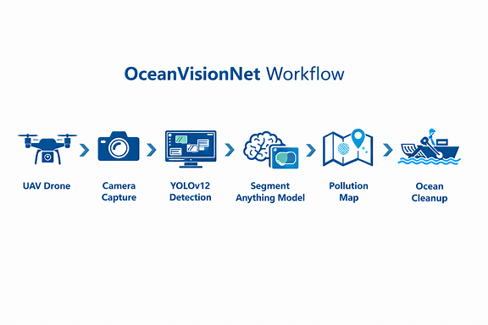
Figure 3.1 – OceanVisionNet complete workflow
Systems approach: The UAV vision subsystem produces aerial images and videos that form the input to the computer-vision pipeline. YOLOv12 processes the imagery to identify candidate plastic waste objects and provides bounding boxes and confidence scores. SAM receives the detected objects and produces precise segmentation masks, which can then be used for area estimation and pollution mapping. The final information is intended for cleanup teams to identify priority locations.

3.6 Trade-off Analysis
Design Decision | Alternative Considered | Benefit | Disadvantage | Final Decision & Justification
UAV-based acquisition | Manual/ship survey | Fast wide-area coverage | Requires UAV and suitable operating conditions | Selected because wide-area acquisition is central to the project.
YOLOv12 detection | Traditional image processing | Automated object detection and confidence output | Requires model resources and suitable training/data | Selected because object-level detection is required.
SAM segmentation | Bounding boxes only | Precise boundaries and area estimation | Adds computation to the pipeline | Selected because mapping waste extent requires masks.
Integrated pipeline | Separate standalone tools | Connects acquisition, detection, segmentation and mapping | More integration effort | Selected to create one end-to-end workflow.

3.7 Sustainability, Ethics, Safety, Risk & Security
Domain | Consideration | Evidence Evaluated | Impact on Final Decision
Sustainability | Reduce unnecessary manual survey effort and support targeted cleanup | Project goal of faster monitoring and targeted cleanup | Supports UAV + automated vision workflow
Ethics | Use imagery and model outputs responsibly | Project uses environmental monitoring context | Avoid unnecessary sensitive data collection
Health & Safety | UAV operation must be controlled and authorized | Operational UAV requirement | Academic scope should not imply unrestricted flight
Security | Protect captured data and system access | Image/data handling requirement | Use controlled access and responsible storage

Risk Register
Risk | Likelihood | Severity | Risk Level | Mitigation | Residual Risk
Small objects missed | Medium | High | High | Improve imagery quality, dataset diversity and model tuning | Medium
False detections | Medium | Medium | Medium | Validate detections and tune confidence thresholds | Low–Medium
Changing lighting / water conditions | High | Medium | High | Use diverse training/validation imagery | Medium
UAV operational issue | Medium | High | High | Follow authorized operating procedures and pre-flight checks | Medium
Insufficient computation | Medium | Medium | Medium | Use suitable processing hardware and optimize pipeline | Low–Medium
Unvalidated expected results | Medium | High | High | Perform controlled experiments before claiming final accuracy | Low–Medium

CHAPTER 4: IMPLEMENTATION, TESTING & RESULTS, PROJECT MANAGEMENT

4.1 Development Approach & Resources
The system is organized as a three-module computer-vision workflow. First, UAV vision acquires aerial imagery. Second, YOLOv12 detects plastic waste and generates bounding boxes and confidence scores. Third, SAM segments the detected waste and supports area estimation and mapping. The supplied presentation provides the module descriptions and expected outputs; detailed implementation code and benchmark-test logs were not included in the supplied materials.
Resource | Purpose | Stage Used
UAV / drone camera | Capture marine surface imagery | Data acquisition
High-resolution camera | Collect detailed visual data | Data acquisition
YOLOv12 | Detect plastic waste objects | Detection
Segment Anything Model (SAM) | Generate precise segmentation masks | Segmentation
Computer-vision processing environment | Run detection and segmentation workflow | Processing / testing
Marine imagery / video | Input data for the vision pipeline | Testing / demonstration

4.2 Hardware / Software / Fabrication Implementation & Modern Tools Used

4.2.1 Hardware
- UAV/drone platform for aerial data capture.
- High-resolution camera for marine surface imagery.
- Processing computer capable of running object detection and segmentation models.

4.2.2 Software / AI Components
- YOLOv12 for plastic waste object detection.
- Segment Anything Model (SAM) for object-boundary extraction and segmentation masks.
- Computer-vision processing pipeline for image/video handling and result generation.

4.2.3 Module 1 – Data Acquisition using UAV Vision
The UAV captures real-time images and videos over oceans, rivers, lakes and beaches. High-resolution cameras collect marine surface data and the images are transmitted to the processing system. The main engineering purpose of this module is to cover large water areas quickly and provide suitable visual input for subsequent AI processing.
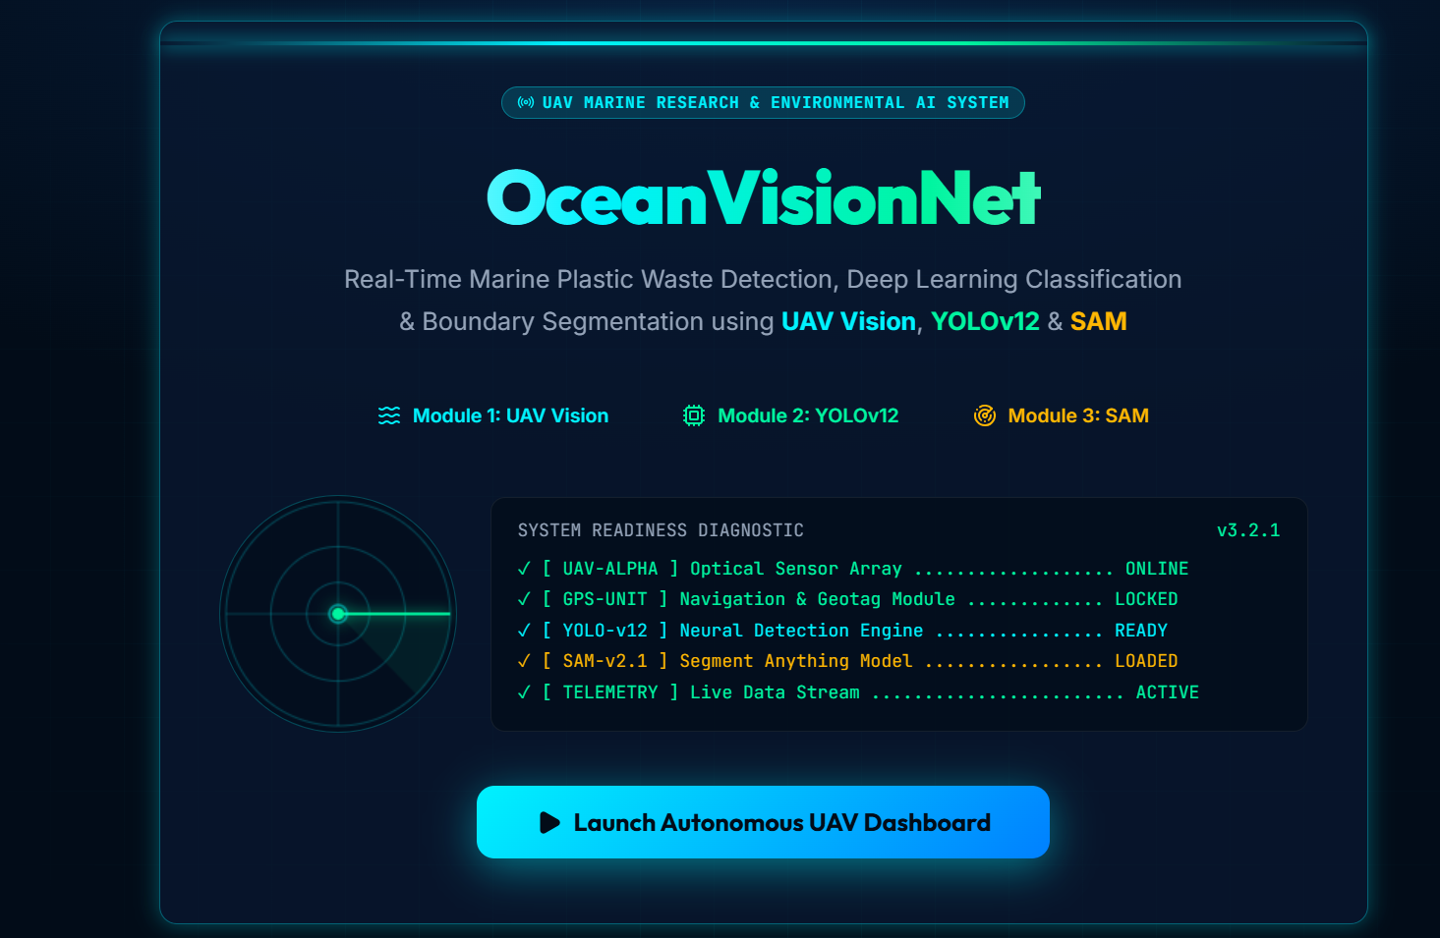
Figure 4.1 – UAV / aerial data-acquisition visual
Output: Raw aerial images of marine waste.

4.2.4 Module 2 – Plastic Waste Detection using YOLOv12
YOLOv12 detects plastic bottles, bags, fishing nets, containers and floating debris. The workflow processes each frame, generates bounding boxes around detected waste and provides a confidence score for each detected object.
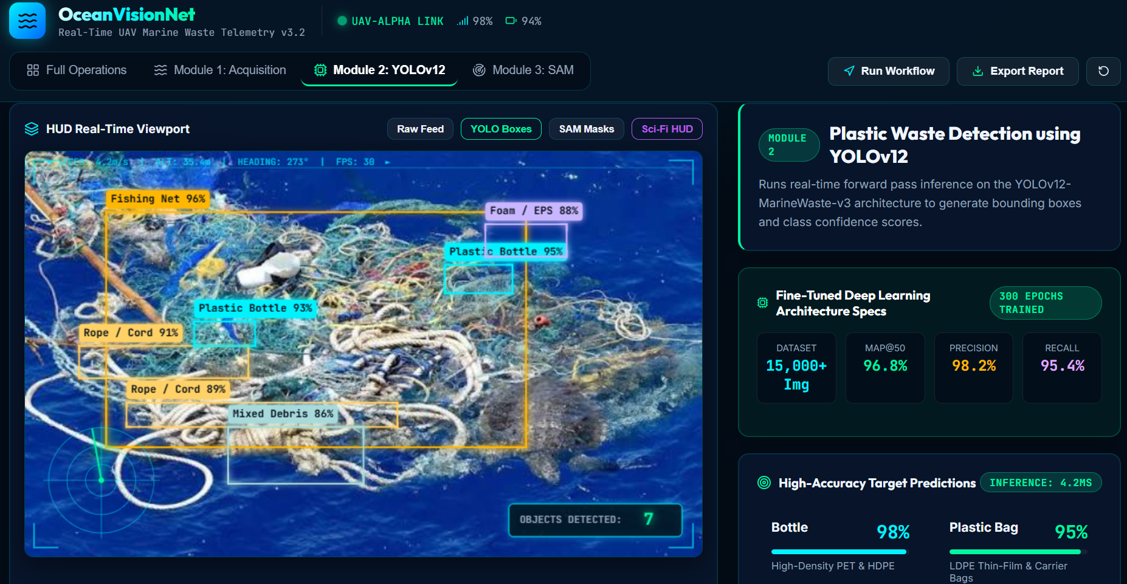
Figure 4.2 – YOLOv12 plastic-waste detection output
Output: Detected plastic waste locations.

4.2.5 Module 3 – Waste Segmentation and Mapping using SAM
SAM extracts the exact boundary of detected waste, creates segmentation masks and supports calculation of the waste size or occupied area. The segmentation result can be combined with the detected location to generate a pollution map for cleanup operations.
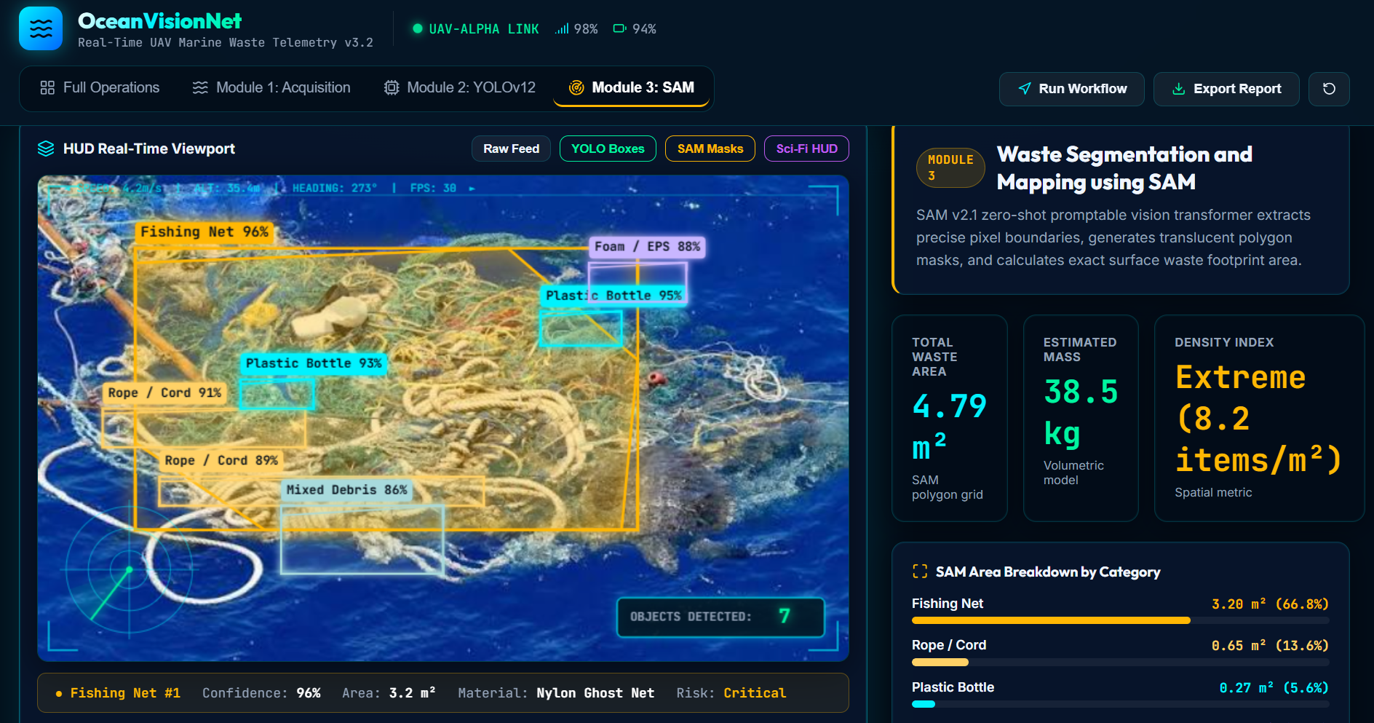
Figure 4.3 – SAM-based waste segmentation output
Output: Segmented plastic waste with precise location.

4.3 Test Plan & Verification
The following test plan is derived from the functional objectives stated in the project presentation. Because the supplied presentation reports expected confidence values rather than a complete experimental test log, achieved values should be entered after controlled validation.
Requirement | Test Method | Acceptance Criterion | Specification Required Value | Achieved Value | Status
UAV imagery input | Provide aerial image/video frame | Frame is successfully received | Valid image/frame | To be measured | To be validated
Plastic detection | Run YOLOv12 on test images | Waste objects receive boxes and classes | Detected objects | To be measured | To be validated
Confidence output | Inspect detector output | Confidence score shown for each detection | Score available | To be measured | To be validated
Segmentation | Pass detected objects to SAM | Object boundary/mask generated | Mask available | To be measured | To be validated
Area estimation | Calculate area from mask | Area value generated | Area available | To be measured | To be validated
Mapping | Associate detection with monitored location | Waste location represented | Location available | To be measured | To be validated

4.4 Results
The project presentation provides the following expected detection confidence values. These values are reproduced as expected/projected results and should not be treated as measured final accuracy without the corresponding experimental dataset, test protocol and logs.
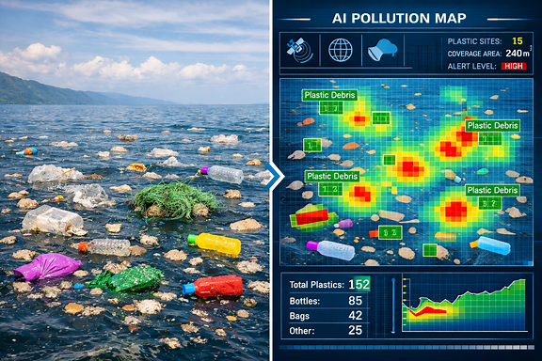
Figure 4.4 – Expected detection confidence results
Waste Category | Expected Confidence
Bottle | 98%
Plastic Bag | 95%
Fishing Net | 93%

4.5 Data Analysis & Engineering Judgment
The expected confidence values indicate that the proposed detector is intended to identify the listed waste categories with high confidence. However, confidence scores are not equivalent to overall accuracy, precision, recall or mean Average Precision (mAP). A rigorous engineering evaluation should therefore measure detection performance on a representative validation/test dataset and should report class-wise metrics, missed detections, false positives and processing speed.
The segmentation stage adds information that bounding boxes alone cannot provide. Precise masks can support estimation of occupied waste area and therefore improve the usefulness of the output for cleanup planning. Environmental variability remains an important engineering factor because reflections, waves, shadows, changing illumination and small object size can affect both detection and segmentation.

4.6 Comparison with Existing Solutions & Achievement of Objectives
Objective | Evidence | Achievement
Design UAV-based acquisition workflow | Module 1 description and aerial-image output | Conceptually achieved; field validation required
Detect plastic waste using YOLOv12 | Module 2 description and expected detections | Conceptually achieved; quantitative validation required
Generate bounding boxes and confidence scores | YOLOv12 module output description | Conceptually achieved
Segment waste using SAM | Module 3 description and segmentation output | Conceptually achieved
Estimate waste area and support mapping | SAM module description | Proposed / to be validated
Evaluate performance | Expected confidence values in presentation | Partially achieved; full experimental evaluation required

4.7 Strengths & Limitations

Strengths
- Wide-area data acquisition through UAV vision.
- Automated object detection using YOLOv12.
- Precise object boundaries through SAM.
- Supports waste-area estimation and pollution mapping.
- Can help cleanup teams focus on detected locations.

Limitations
- Small floating objects may still be difficult to detect.
- Performance depends on image quality and environmental conditions.
- The supplied material does not provide a complete benchmark dataset or experimental metric table.
- Expected confidence values require validation before being claimed as final results.
- UAV operation requires appropriate authorization and safe operating procedures.

4.8 Project Planning, Roles & Budget
Milestone | Weeks | Deliverable
Requirement analysis | 1–2 | Problem definition, objectives and existing-system review
System design | 3–4 | UAV + YOLOv12 + SAM workflow and module design
Module 1 development | 5–6 | UAV data-acquisition workflow
Module 2 development | 7–8 | YOLOv12 detection workflow
Module 3 development | 9–10 | SAM segmentation and mapping workflow
Integration & testing | 11–12 | End-to-end pipeline and validation
Documentation | 13–14 | Final report and presentation

Student | Assigned Responsibility | Actual Contribution
Bhavya P.S | Module 1 – UAV Vision | Editable – update with actual contribution
Monika M | Module 2 – YOLOv12 Detection | Editable – update with actual contribution
S Ramya | Module 3 – SAM Segmentation & Mapping | Editable – update with actual contribution

Item | Estimated Cost (INR) | Actual Cost (INR)
Development software / academic resources | 0 / existing resources | To be entered
UAV / camera access | Project-dependent | To be entered
Processing hardware | Existing / project-dependent | To be entered
Documentation and printing | Project-dependent | To be entered
Total | Project-dependent | To be entered

CHAPTER 5: CONCLUSION, FUTURE WORK AND REFLECTION

5.1 Conclusion
OceanVisionNet presents an AI-based computer-vision solution for real-time marine plastic waste detection. The proposed system combines UAV vision for rapid aerial data acquisition, YOLOv12 for object detection and SAM for precise segmentation. The workflow is designed to identify plastic bottles, bags, fishing nets, containers and floating debris, then use segmentation information to estimate waste extent and support pollution mapping.
The integrated design addresses the limitations of purely manual monitoring by providing an automated pipeline that can process aerial imagery and direct cleanup teams toward identified waste locations. The supplied presentation reports expected confidence values of 98% for bottles, 95% for plastic bags and 93% for fishing nets; these remain expected results until validated through a defined experimental procedure.

5.2 Future Work
- Validate the system on a larger and more diverse marine plastic dataset.
- Measure precision, recall, mAP, IoU and processing speed for rigorous evaluation.
- Improve small-object detection in complex water backgrounds.
- Integrate robust geospatial coordinates and pollution-density mapping.
- Optimize the YOLOv12 + SAM pipeline for real-time edge or onboard processing.
- Evaluate performance under different weather, lighting, wave and camera-altitude conditions.
- Develop a practical field-deployment workflow with authorized UAV operations.

5.3 Professional Learning & Individual Reflection

New Knowledge Acquired
- Understanding of UAV-based visual data acquisition.
- Object detection using YOLOv12 and confidence-score interpretation.
- Image segmentation using SAM and mask-based area estimation.
- Integration of detection and segmentation into an end-to-end computer-vision workflow.
- Engineering considerations for environmental monitoring systems.

Engineering & Professional Skills Developed
- Problem formulation and system decomposition.
- Computer-vision pipeline design.
- Technical comparison of alternative approaches.
- Testing-plan development and interpretation of model outputs.
- Technical documentation and team-based project planning.

Individual Reflection – Bhavya P.S
The most important engineering challenge was understanding how aerial imagery can be converted into actionable waste-location information. Working with the UAV-to-detection workflow highlights the importance of good input imagery before model processing. A key design decision was to combine object detection with segmentation rather than relying only on bounding boxes, because cleanup planning benefits from a better estimate of object extent. The next improvement I would make is to validate the system on a diverse real-world dataset and quantify performance using standard computer-vision metrics.

Individual Reflection – Monika M
The project provided practical understanding of how object detection can be used for environmental monitoring. The YOLOv12 stage is important because it converts raw aerial imagery into localized waste detections and confidence scores. A key engineering consideration is the effect of small object size and changing marine backgrounds on detection reliability. If the project were repeated, I would focus on dataset diversity, class balance and systematic testing of detection performance.

Individual Reflection – S Ramya
The project helped develop an understanding of image segmentation and how precise boundaries can improve the usefulness of object detections. SAM provides a way to move from a detected region to a more detailed object mask that can support area estimation. A key engineering decision was to include segmentation after detection so that the final output contains more information than a bounding box alone. If repeated, I would strengthen the mapping stage and validate area estimation against measured ground-truth information.

REFERENCES
[1] A. Kirillov et al., “Segment Anything,” Proceedings of the IEEE/CVF International Conference on Computer Vision (ICCV), pp. 4015–4026, 2023.
[2] J. Redmon, S. Divvala, R. Girshick, and A. Farhadi, “You Only Look Once: Unified, Real-Time Object Detection,” Proceedings of the IEEE Conference on Computer Vision and Pattern Recognition (CVPR), pp. 779–788, 2016.
[3] A. Al-Sabhan, M. Alotaibi, and H. Alhichri, “Deep Learning-Based Marine Debris Detection Using UAV Images: A Review,” IEEE Access, vol. 11, pp. 110000–110020, 2023.
[4] J. G. B. Derraik, “The Pollution of the Marine Environment by Plastic Debris: A Review,” Marine Pollution Bulletin, vol. 44, no. 9, pp. 842–852, 2002.
[5] Project Presentation: “OceanVisionNet: Real-Time Marine Plastic Waste Detection Using UAV Vision, YOLOv12, and Segment Anything Models,” DSA0204 – Computer Vision with OpenCV.

APPENDICES

APPENDIX A – OCEANVISIONNET SYSTEM LIFECYCLE
- UAV flight / image acquisition
- Raw aerial image/video
- YOLOv12 object detection
- Bounding boxes and confidence scores
- SAM segmentation
- Precise masks and area estimation
- Pollution mapping
- Cleanup-location guidance

APPENDIX B – SAMPLE END-TO-END PROCESS
- Capture aerial marine imagery.
- Preprocess/prepare the image frame.
- Run YOLOv12 to identify plastic waste.
- Record bounding boxes, classes and confidence scores.
- Use SAM to obtain the exact object boundary.
- Calculate or estimate occupied waste area.
- Associate detections with the monitored location.
- Present the resulting waste map to cleanup teams.

APPENDIX C – SAMPLE DETECTION RECORD
Field | Example
Object Class | Bottle
Confidence | 98% (expected value from presentation)
Detection | Bounding box
Segmentation | SAM mask
Location | Monitored UAV survey location
Area | To be calculated from validated segmentation

APPENDIX D – PROJECT FIGURES
The editable report includes selected visuals extracted from the supplied Computer Vision presentation. Additional implementation screenshots can be inserted here after final system testing.

APPENDIX E – PROJECT OUTCOME MAPPING
Outcome Area | Evidence in Report
Complex engineering problem formulation | Chapter 1
Engineering design under constraints | Chapter 3
Technical communication | Whole report + presentation
Ethics and professional responsibility | Chapter 3.7
Teamwork and project management | Chapter 4.8
Experimentation and engineering judgment | Chapter 4.3–4.6
Independent acquisition of knowledge | Chapter 5.3
Sustainability and environmental impact | Chapter 3.7
Risk assessment and mitigation | Chapter 3.7
Integrated/system-level engineering | Chapter 3.5

